Separation Anxiety

In early childhood, school is one of the first places where separation anxiety and related anxious behaviours may manifest, as it represents a change in routine for both children and parents.

Children have spent a lot of time at home with their parents/carers due to schools being closed as a result of the COVID-19 pandemic. Feeling safe may have come to be associated with ‘staying at home’, ‘social distancing’ and frequent hand washing and so children will need to learn new ways to continue to feel safe now that children are back in school.

Children may respond to the return to school in different ways. The return to school may feel been a relief, or even exciting for some. However:
- Many children are still experiencing worries about coming to school and leaving their parents/carers after time at home. It is important to validate and normalise these worries.
- Some children may have felt safe at home or in bubbles and/or enjoyed learning in a quieter/calmer environment, so adjusting to full classes and assemblies, where everything is louder and busier may be difficult.
- Children and young people who previously had difficulty coming into school and leaving their parent or carer may be finding this return to school particularly challenging.

Parents/carers can also be anxious about their child returning to school as they may not feel it is safe for them or that their needs are being listened to. Their child may appear fine in school (masking) but may talk about their difficulties at home or have meltdowns/display challenging behaviour once they are at home. It is important to work with families to support them to navigate these difficulties and provide reassurances and clarity of information.

For some children the anxiety will be overwhelming and the thought of leaving their parents(s)/carer(s) may result in difficulties attending school or emotionally based school avoidance. The following strategies and activities may help support children who are experiencing these difficulties. It is important to develop bespoke interventions for each child based upon their unique needs:

 | - Create a plan of what is going to be put in place. Ideally this should be produced in collaboration with the child and their parents /carers to reduce the fear of uncertainty. Set short- and long-term targets/weekly goals. It is very important to celebrate the achievements and progress – however small!
 | - In collaboration with the child’s parents/carers, agree a goodbye ritual/script or special handshake (e.g. a hug and two kisses). Try and avoid prolonged goodbyes which then increases the child’s anxiety, create predictability and consistency around school drop off.
 | - Make sure a key/trusting adult is able to meet the child at the beginning of the day. Or have a friend meet them at the start of the day to engage in an enjoyable activity together.
 | - Agree a transitional object for the child to keep with them at school: small felt hearts with comforting scent, small photo of parent/carer, bracelet for the child/adult to swap, comforter (teddy/blanket).
 | - Provide the child with lots of positive encouragement following successful separations. It is very important for there to be a positive interaction when the child first gets to school.
 | - Start the day with a low pressure or soothing activities e.g. breathing, mindfulness, ‘toast club’, a meaningful ‘special’ job for the child to do when they first come into school. This is so they don’t have to go into a situation of high expectation or pressure.
 | - Graded exposure works by carefully exposing the child to separation in small, controlled steps. This increases the child’s capacity to manage distance from the parent/carer, helping to reduce their worry over time. This should be collaborative work with the school, child and parent/carer.
 | - Support the child to manage their worry/anxiety. It can be helpful to support the child to project the anxiety onto something else (metaphorically). Is the child able to draw the anxiety out? Work with the child to understand their anxiety and the push/pull factors that are affecting their school attendance.
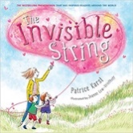  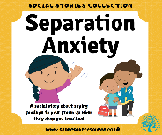 | - Create social stories about leaving their parent/carer and saying goodbye. Read this daily at home and at school to reduce uncertainty and increase predictability.  - Books can be used as part of a toolkit to support children experiencing separation anxiety (or loss and grief):  - The Invisible String  - The Kissing Hand  - What to Do When You Worry Too Much  - The Huge Bag of Worries  - What to Do When you Don’t Want to Be Apart  - Starving the Anxiety Gremlin: CBT Workbook

Top tips

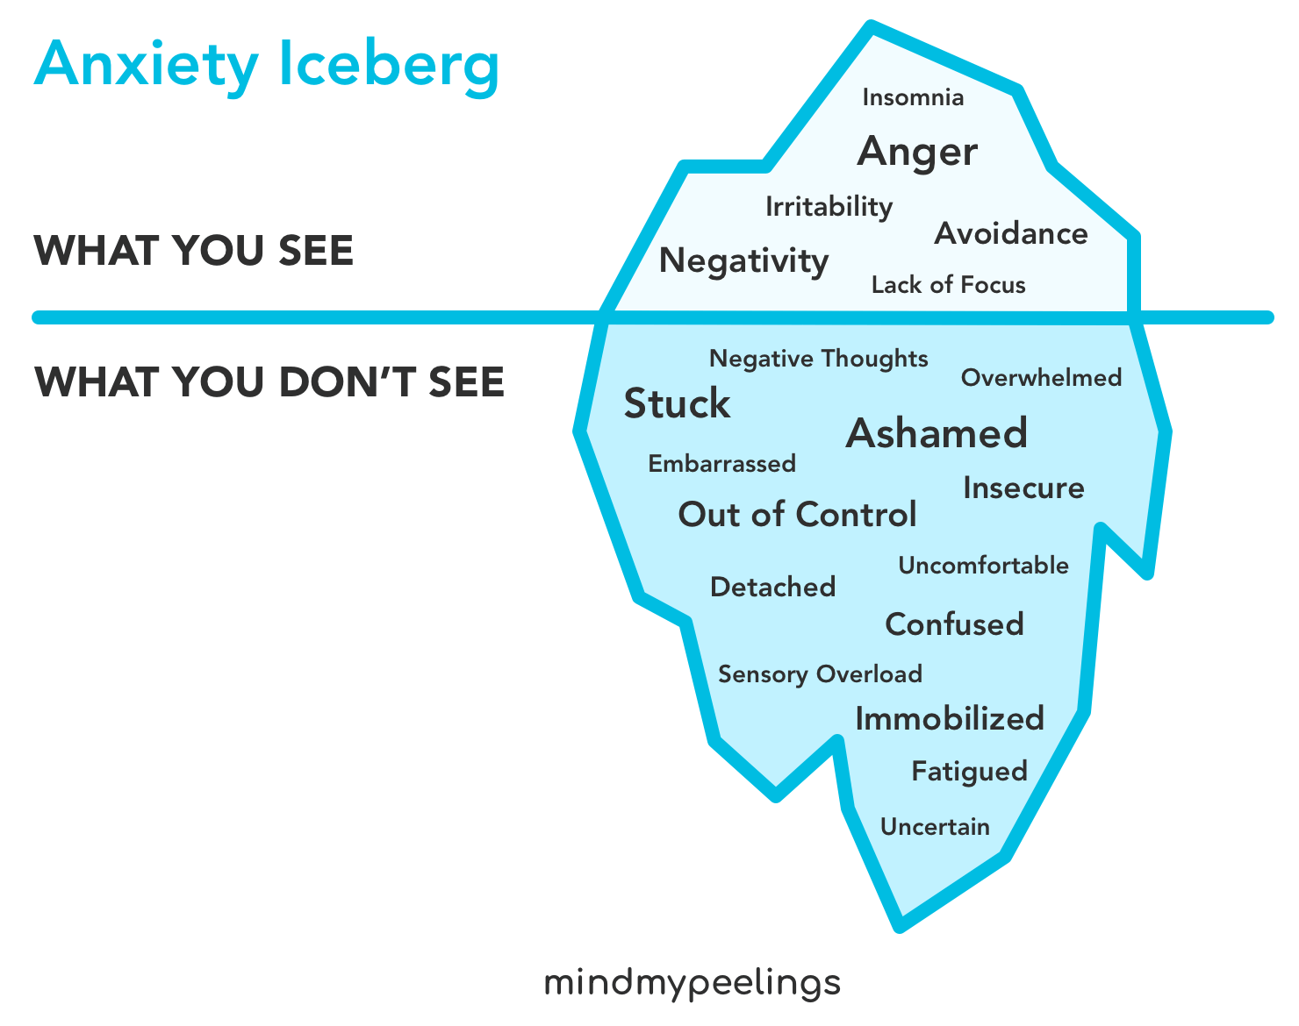
- Work in collaboration with the child and the family
- Take time to listen and explore the child’s anxieties and worries. Use the Anxiety Iceberg to think through the potential causes for the anxiety. Start with the behaviours you can see (above the water) and talk about the other feelings that might be hiding under the water.
- Instil confidence in the child – teach them that even though something feels scary – the feeling will pass and they will be OK. Building up this tolerance when facing small fears will help them to feel confident and capable when encountering larger fears. Praise them for trying and help to make them feel successful by overcoming something so challenging.
- Don’t automatically remove the trigger – listen to the child and validate their worries but also help them to learn to tolerate uncomfortable feelings in a supported manner.
- Practise building up time/space between the child and parent, so that there is increased tolerance to being apart that can help at school.
- Parents should try not to let their child see/feel their worries. They should be positive about school and not talk negatively about school in front of the child as this will reinforce any anxieties.
- Celebrate progress, regardless of how small!
- The initial transition is the most difficult; therefore, make sure there is a positive interaction with a key adult and enjoyable/relaxing activity for the child to engage in when they first come back to school.
- Some children/young people may need specialist support to help them manage their anxieties and separation from parents. It would be appropriate to refer parents to their GP or to CAMHS for support with this.

