

West Berkshire Fair Access Protocol
Ensuring Equitable Access to Education for Vulnerable and Unplaced Pupils





CONTENTS
Contents 1
Context 2
Monitoring the Fair Access Protocol 4
Publication and Review of the Fair Access Protocol 4
The Fair Access Panel & Procedures 4
Who can Refer to Fair Access Panel 7
Challenging behaviour 7
Definition,Process & Local Authority DUTY 7
Local Authority referrals for unplaced pupils and Children Missing Education (CME) 9
FAP considerations 10
The needs of the child: 10
The views of the school: 10
Parental preference: 10
Placement rationale 10
Options for admission 12
The ROLE OF iCOLLEGE (PRU) 13
Decisions and appeals 13
Arrangements for Being Taken on Roll 14
Directions 15
West Berkshire Council Directions 15
Secretary of State Directions 15
Published Admission Number (PAN) 16
Appendix A - FAPP Referral Form 16
Appendix B – FAP Referral Form on grounds of challenging behaviour 21
Appendix C - Decision Making Method 22
Appendix D - Additional Funding Decision Method 23
Appendix E - FLOWCHARTS – Successful/unsuccessful direction 24
Appendix F – Pupil Placement Panel 26
Appendix G - Data sharing protocol to support Fair Access Panel 28
Key Principles: 28
Appendix H - Parental Views for Consideration at FAP 30

CONTEXT
This protocol is underpinned by national legislation and guidance as well as local policies and procedures:
- School admissions code 2021 (publishing.service.gov.uk) (September 2021)

Fair Access Protocols in School Admissions, Department for Education Guidance (November 2012)

Fair access protocols: advice for local authorities and school admission authorities (publishing.service.gov.uk) (August 2021)

The Education (Pupil Registration) (England) Regulations 2006

The Education (Pupil Registration) (England) (Amendment) Regulations 2016

School Standards and Framework Act 1998

The School Admissions (Admission Arrangement and Co-ordination of Admission Arrangement) (England) Regulations 2012

Equality Act 2010

Human Right Act 1998

Exclusion guidance

West Berkshire Council School Admission Arrangements

This protocol applies to all West Berkshire admission authorities (i.e., maintained schools, voluntary aided schools, academies, and free schools). The term ‘schools’ should be taken to mean the aforementioned educational settings. The term ‘parents’ should be taken to mean parents, carers, or those with parental responsibility for the child.

- The School Admissions Code (September 2021) requires the Local Authority (LA) to have a Fair Access Protocol (FAP), agreed with the schools in its area, to ensure that unplaced and vulnerable children, and those who are having difficulty in securing a school place, are allocated a suitable school place as quickly as possible.

- The protocol applies to the admission of pupils to schools in West Berkshire outside of the normal point of admission. Therefore, a referral to FAP is the result of a pupil requiring placement in-year and should only take place if it can be demonstrated that reasonable measures have been taken to secure a place through in-year procedures and that the pupil meets one of the prescribed categories of children eligible to be placed under the protocol.

- This protocol ensures all schools are treated fairly and consistently, preventing any one school from receiving a disproportionate number of pupils placed via FAP.

- The protocol will also determine how the needs of children who have been permanently excluded, and children for whom mainstream education is not yet possible, will be met.

- The FAP can only be used to place the following prescribed categories1 of children of statutory school age where they are having difficulty in securing a school place:

  - Children either subject to a Child in Need Plan or a Child Protection Plan or having had a Child in Need Plan or Child Protection Plan within 12 months at the point of being referred to the protocol;
  - children living in a refuge or in other relevant accommodation at the point of being referred to the protocol;
  - children from the criminal justice system;
  - children in alternative provision who need to be reintegrated into mainstream education or who have been permanently excluded but are deemed suitable for mainstream education;
  - children with special educational needs (but without an Education Health and Care Plan), disabilities or medical conditions;
  - children who are carers;
  - children who are homeless;
  - children in formal kinship care arrangements2;
  - children of, or who are, Gypsies, Roma, Travellers, Refugees and Asylum seekers;
  - children who have been refused a school place on the grounds of their challenging behaviour and referred to the protocol;
  - children for whom a place has not been sought due to exceptional circumstances;
  - children who have been out of education for four or more weeks where it can be demonstrated that there are no places available at any school within a reasonable distance of their home. This does not include circumstances where a suitable place has been offered to a child and not accepted
  - previously looked after children for whom the local authority has been unable to promptly secure a place.

Locally agreed exceptional circumstances categories:

  - Children returning from Elective Home Education particularly when it is judged to be unsatisfactory
  - Children coming into the LA who are currently in a PRU or AP

- As other legislation and processes are in place, accessing FAP is not possible if:

- the child has an Education Health and Care Plan (EHCP)
- the child is a Child in Care (CIC)

- It is also expected that previously looked after children (PLAC) or previously looked after children from state care outside of England (IPLAC) would not be required to be referred to FAP as they would normally be considered on the same basis as CIC. The provision within the prescribed categories for these children should only be necessary if a school place has not been secured promptly.

- There is a presumption that pupils with SEND should have their needs met, including reasonable adjustments, in mainstream settings. Referrals to FAP should only be in exceptional circumstances and where strong evidence suggests an EHCP process should ordinarily have been pursued.

1As defined in the School Admission Code, 2021, paragraph 3.17
2As evidenced by child arrangements order not relating to either birth parent or a special guardianship order

MONITORING THE FAIR ACCESS PROTOCOL
- West Berkshire’s FAP Officer will monitor placements made under the Fair Access Protocol (FAP) and the operation of the Fair Access Panel, to ensure an equitable decision-making process.

- A termly record of decisions made under the FAP will be maintained by West Berkshire’s FAP Officer and reviewed annually. This record will form part of West Berkshire’s termly reporting process of school performance to the Children’s Services Leadership Team and schools, via the Schools Forum.

- The Fair Access Panel will receive an annual report on in-year admissions for each academic year, which will include the number of admissions made under the FAP. This report will be publicly available – therefore the identities of individual children will be anonymised.

- An annual report on the number of children admitted under the FAP, produced by West Berkshire’s FAP Officer, will also be made available to the Office of the Schools Adjudicator (OSA).

PUBLICATION AND REVIEW OF THE FAIR ACCESS PROTOCOL
- The Fair Access Protocol will be published on the Admissions page of West Berkshire website and will form part of the admissions arrangements for all state-funded mainstream schools in West Berkshire.

- The FAP will be reviewed annually. Reviews will be led by West Berkshire’s FAP Officer, in consultation with all schools across the authority. Any changes to the FAP will be consulted on with all schools (requiring 51% of schools to approve), before being submitted to the Children Services Leadership Team for approval. Whilst a majority agreement of all schools is legal there will be consideration to the approval split of Primary and Secondary schools.

- If most schools can no longer support the principles and approach of the local FAP (for example, if they believe it is not operating fairly or effectively), they may request that it is reviewed. The mechanism for invoking a review will be to submit the request in writing to the Director of Education and the existing FAP will remain binding on all schools in the area until a new one is adopted.

THE FAIR ACCESS PANEL & PROCEDURES

In West Berkshire there is 1 Fair Access Panel meeting which encompasses:
- PPP meetings described in APPENDIX F which focuses on placements at iCollege, long term alternative learning provision placements and short-term places. This meeting can be used to discuss managed moves and/or Direction off site where appropriate and at schools’ discretion, and on dual registration;
- FAP meetings which will be called when required for other unplaced children where it has not been possible to allocate through the normal process. This policy focuses on this definition.

- West Berkshire’s Fair Access Panel consists of a representative from every mainstream Secondary establishment in the area, two Primary representatives, the FAP Officer, Principal Education Welfare Officer, Admissions Manager, Exclusions and Re-integrations Manager, and the Head of iCollege. School members should be the Headteacher or their representatives (in exceptional circumstances) who have been designated to make decisions on behalf of the school. Representation is expected for every meeting.

- Other contributors to panel may include further colleagues from the Local Authority such as:
- Governor support
- School Improvement Team
- SEND Team
- Pupil Place Planning
- Integrated Early Help Service/Social Worker
- CME Officer

These officers would typically attend in an advisory role, and they would not vote in any decisions taken3.

- For expediency, decisions will be taken if there are a minimum of five West Berkshire school representatives present at the meeting. In the event of a split decision and where the vote is tied, further discussion will take place to reach a majority vote but if this is not possible the Chair of panel will make a casting vote.

- No school can abstain from voting.

- West Berkshire operates a combined primary/secondary Fair Access Panel meeting so referrals of pupils from both sectors would be heard by the same panel. In the event of a primary referral being made to panel, a representative from the individual primary school/s, in addition to the regular panel members, will be invited to attend to present a school perspective, but this can also be done by written submission to panel.

- Prior to the main FAP meeting including all representatives, a pre-meeting will be held 4 days prior to the FAP Panel including, the Head of iCollege, FAP Chair, FAP Officer, Admissions Manager, Exclusions and Re-integrations Manager to discuss the referrals and give an indication to the meeting of the 3 most appropriate placements and types of intervention support available to advise the FAP Panel. This is not a decision-making meeting. Final decisions regarding allocations of placement will only be made in the FAP Panel with the full information available to inform.

- The Chairing of panel is a neutral role to facilitate effective decision-making and is undertaken by a person independent of the Local Authority; the panel will elect a vice chair from within its membership. Where the Chair and Vice Chair are unable to attend a panel meeting, a temporary chair will be elected for that meeting.

3Panel members would be notified in advance of the meeting when a colleague has been requested to attend in an advisory role for any specific case

- Clerking facilities, including all administrative duties, remain the responsibility of the LA and are undertaken by the FAP Clerk and include:

- Inform the parent that the application has been referred to FAP;
- Ensure that the application form has been fully completed and returned by the current/ previous school /Admission Authority if applicable;
- Ascertain whether the pupil is known to other agencies such as SEND, YOS or CSC;
- Request further information, if necessary. The papers will be prepared on the understanding that more information will facilitate naming the most suitable school.
- Ascertain whether there is a potential conflict of interest and, if so, to discuss with the panel member and seek an alternative panel member if both agree a conflict exists;
- Ensure that appropriate schools are represented (whereby if a referring school is required to attend and or possible receiving school and outside of regular panel members
- Circulate the paperwork to the panel members 3 school days in advance of the meeting.

- The Fair Access Panel will meet during the regular PPP meetings set dates, once every half term. The agenda will be organised on receipt of a referral due to the swift nature of placement. Panel members should make this meeting a priority. The deadline for referrals to FAP to be placed on the agenda is 7 school days before the meeting. Wherever possible, a summarised referral agenda will be sent to designated school email addresses 3 school days in advance of the meeting and
a further email, confirming key decisions made, and any required actions, will be issued the next working day after panel have met4. There may be occasions where an additional meeting is called to expedite swift placement of pupils and these will be virtual for ease.

- FAP Referral Forms should be completed by the referrer and emailed to admissions@westberks.gov.uk and FAP@westberks.gov.uk the referral form can be found in APPENDIX A.

- To ensure the Fair Access Panel has a full picture of the equitable way that all schools are working together, cumulative data of in-year admissions and FAP placements will be available throughout the year. This information will be collated by the FAP Clerk and presented at each meeting.

- Information regarding previous pupil placement panel referrals and permanent exclusions will be available

- The statistical data listed below will be provided to the panel for each school, some of which is based on the last census data:
- The number of pupils on the school roll;
- Number and percentage of pupils admitted to the school via the in-year admission process since the beginning of the school year;
- Number of pupils in each year with Education, Health and Care Plans;
- Number and percentage of permanent exclusions in each year group during the last school year;
- Number of pupils admitted to schools via the in-year process since the beginning of the school year because the pupil meets the definition of challenging behaviour;

4if the meeting day is changed, either on a temporary or more permanent basis, the schedule will be adjusted in accordance with the described timeframes.

- The number of confirmed placements through Pupil Placement Panel since the beginning of the school year;
- The number of pupils admitted to schools via the Fair Access Protocol under all of the categories;
- The number of pupils admitted on a Managed Move & Off-Site Directions

- Parents are not permitted to attend Fair Access Panel meetings but may submit a representation for consideration by the Panel if they wish to do so. A referral form will be sent to them to complete in advance of the meeting – see APPENDIX H

WHO CAN REFER TO FAIR ACCESS PANEL
- Admission Authorities must consider all formal in year applications submitted and must not refuse to admit a pupil unless to do so would prejudice the provision of efficient education and efficient use of resources in the school. In the exceptional circumstance that a school, who has an available place, feel the admission of an individual pupil would prejudice the efficient delivery of education and efficient use of resources and that pupil meets one of the prescribed categories, the admission authority/school are required to inform the School Admissions Team in the Local Authority by submitting a FAP referral and the application may be presented for consideration by West Berkshire Fair Access Panel, if eligible.

- Internal West Berkshire referrals can be made from Children Missing Education (CME) Officer, Admissions Manager or iCollege.

- It is the responsibility of the referring school/team to ensure all documents are sent to the Admissions Manager.

CHALLENGING BEHAVIOUR

DEFINITION,PROCESS & LOCAL AUTHORITY DUTY

- Admission authorities must not refuse a child based solely on perceived disruptive behaviour, unless specific legal criteria are met.

- A child with challenging behaviour5 may also be disabled as defined in the Equality Act 2010. When considering refusing admission on these grounds, admission authorities must consider their duties under that Act. Admission authorities must consider their duties under that Act. Admission authorities should also consider the effect of the decision of the Upper Tribunal in C & C v The Governing Body of a School, The Secretary of State for Education (First Interested Party) and The National Autistic Society (Second Interested Party) (SEN): [2018] UKUT 269 (AAC) ; [2019] AACR 10 - GOV.UK (www.gov.uk) when a pupil exhibits a tendency to physical abuse of other persons as a consequence of a disability.

5The Admission Code defines behaviour as challenging where it would be unlikely to be responsive to the usual range of interventions to help prevent and address pupil misbehaviour or it is of such severity, frequency, or duration that it is beyond the normal range that schools can tolerate and significantly interfere with the pupils/other pupils’ education or jeopardise the right of staff and pupils to a safe and orderly environment.

- Local Authorities (LAs) have a duty to ensure that all children have access to education, including those who may exhibit challenging behaviour. Schools can refuse admission under certain circumstances, but West Berkshire will oversee the process to ensure fairness and compliance with statutory guidance. West Berkshire will ensure that schools follow fair and lawful admissions processes, particularly when rejecting applications due to challenging behaviour. The decision-making process involves several key considerations:

Compliance with the School Admissions Code:

Schools can only refuse admission based on challenging behaviour if:
  - The application is for an in-year admission (not the normal entry point).
  - The school has a particularly high proportion of pupils with challenging behaviour or previous exclusions compared to other local schools.
  - Admitting the pupil would prejudice the provision of efficient education or use of resources.

Fair Access Protocol (FAP) Review

  - If a school refuses admission, the LA must assess whether the pupil qualifies for placement under the Fair Access Protocol (FAP). This will be completed by the Admissions Manager, FAP Officer and a Secondary Head representative.
  - The FAP ensures that vulnerable and hard-to-place children are allocated a school place quickly

Consideration of Individual Circumstances

  - The LA must ensure that the rejection is not discriminatory and aligns with Equality Act 2010 protections.
  - Schools cannot refuse admission for:
- Children in Care or previously looked-after children.
- Pupils with an EHCP
- Pupils who may require SEND assessment.

Oversight & Appeals

  - Parents have the right to appeal a rejection, and the LA must facilitate this process.
  - The LA may challenge a school’s refusal if it believes the decision was unjustified or inconsistent with local policies or admission code.

- Admission authorities cannot make referrals on the grounds of challenging behaviour in respect of the following pupils:

- looked after children (LAC) and previously looked after children (PLAC).
- children who have an Education, Health and Care Plan naming the school.
- children applying in the normal admissions round or at any point in the normal year of entry (unless the child has been excluded from two or more schools with the most recent exclusion being within the last 2 years).
- Children of UK service personnel and crown servants

- If an admission authority presents a case that demonstrates a high proportion of children with challenging behaviour or previously permanently excluded pupils on roll, this will remain a valid case for the remainder of the school term in which it is presented in relation to all subsequent referrals.

- Where a school has applied to FAP due to ‘challenging behaviour’ the applying school will abstain from voting. It is lawful for the fair access protocol meeting (which will include representatives of the school) to ask a school to admit a child despite the school having referred the child to the FAP for challenging behaviour.

The process flowchart for directions can be seen at APPENDIX E

LOCAL AUTHORITY REFERRALS FOR UNPLACED PUPILS AND CHILDREN MISSING EDUCATION (CME)
- Local Authorities have a duty to ‘make arrangements’ to identify children in their area who are not registered pupils at a school and are not receiving suitable education otherwise and to act on this. Without parental engagement (i.e. the completion of an in-year application form to actively seek a school place) the LA may progress with a School Attendance Order (SAO). The Local Authority will name a school on the order based on schools with places in that school year and within reasonable distance from the pupil’s residence. If this is not possible then a referral to FAP will be made under the criteria (l) and may include pupils registered as EHE but for whom the LA has deemed education delivery as unsuitable6. Pupils receiving EHE in accordance with parent choice, will NOT be eligible for FAP referral if EHE is deemed suitable by the LA Officer

- The panel should, where appropriate and safe to do so, return a pupil who is returning to a mainstream setting within a year following being electively home educated, to their last provision. This does not invalidate the normal admissions process, and parents can still submit a parent led school place application.

- Where a pupil has been offered a place at a school and parents have rejected the place, leaving the pupils without a school place, the CME Officer will contact the parents and discuss the education provision in place for the pupils and decide on next steps including a School Attendance Order.

- The Local Authority monitors in-year transfer applications and may refer an application to panel for a placement decision if the pupil is an unplaced West Berkshire resident and a place has not been secured through the typical in-year application process in a timely manner (i.e., more than
10 school days). This could include where an application has been made but parental preference cannot be met due to oversubscription. In these cases, panel may be asked to discuss and agree an alternative placement offer to be made to the pupil7. The appeals process is independent from the FAP. Where a child has been referred to the FAP, their parents retain the right to make further in-year applications and appeal against the refusal of a school place as normal.

6The provisions stated within 8.1 and 8.2 is intended to ensure that no single school is asked to take a disproportionate number of pupils being placed via the protocol (see also 9.7).
7The provisions stated within 8.2 would typically only be used if the child meets a prescribed category.

- Admission authorities should be aware that where they refuse a child a school place and subsequently refer them to the FAP, they may later be required to admit that child if an appeal is upheld. This would still be the case when an alternative school place is offered to the child via the FAP. In all circumstances, the decision of an appeal panel is binding and must be complied with. The fact that an appeal has been lodged for a child is not a reason to delay the FAP process.

- On occasion, it is recognised that, for children in vulnerable categories or those with challenging behaviour, it may not be appropriate to place in a particular school or it may be that only one school may meet their particular need. This would only occur in limited circumstances such as:
- there may be safeguarding reasons for a child in a refuge to attend the local school;
- A court order or bail conditions preventing attendance at a particular school.

- Where this occurs, a professional, including LA officers, can make an application through FAP for an exceptional referral. It is for the local authority to decide whether a child qualifies to be placed via the Protocol, based on the circumstances of the case. This does not invalidate the
normal admissions process.

FAP CONSIDERATIONS

THE NEEDS OF THE CHILD:

- Children eligible to be placed via FAPs are often vulnerable and may have additional needs that require support. Before making placement decisions, consideration should be given as to whether a child has any needs, and which school might best be able to meet and support those needs.

- The importance of contextual safeguarding and peer relationships that may impact on the success of the placement will be considered and discussed

THE VIEWS OF THE SCHOOL:

- All schools should be treated in a fair, equitable and consistent manner. This means that no school – including those with places available – is asked to take a disproportionate number of children who have been permanently excluded from other schools, who display challenging behaviour, or who are otherwise being placed via the FAP.

- Where a school expresses compelling reasons for not being able to admit a child via the FAP, for example due to health and safety reasons, this should be taken into consideration before a decision is made to place a child in that school.

PARENTAL PREFERENCE:

- There is no duty for local authorities or admission authorities to comply with parental preference when allocating places through the FAP, but parents’ views should be considered. Information from a parent can provide valuable context that may help those involved in the FAP process determine whether a particular school place is appropriate for a child, and any needs they may have.

PLACEMENT RATIONALE
- The panel is obligated to agree a placement for any West Berkshire resident pupil who presents as unplaced (not on a school roll) or is unable to access their last provision (for example due to distance or travel constraints if the child has moved into the area).

- FAP recognises the need for admission authorities, school leaders and local authorities to work collaboratively, considering the needs of the child and the views of the school where the child might be placed.

- Unplaced West Berkshire resident pupils in all Key Stages whose previous educational placement was a PRU/equivalent alternative provision (typically on a single-registration basis), or those who have been permanently excluded, will ordinarily be placed on the roll of West Berkshire PRU (iCollege) for assessment. This can take place without the need for an initial discussion at FAP and will be decided by the Head of Education at West Berkshire Council.

- For unplaced West Berkshire resident pupils who have been referred to FAP under other prescribed categories, and where panel agree that a mainstream setting would not be appropriate, a placement can be made at the Local Authority PRU for assessment. Funding for the placement will be through section 19 and the High Needs Block.

- Professionals at West Berkshire iCollege (PRU) will determine when a pupil who is of single registration is ready to be reintegrated into mainstream education and they will refer that pupil to FAP for placement.

- Where FAP determine that a mainstream school place is the most appropriate placement for an unplaced West Berkshire resident pupil who has been referred to panel under any category, an open and transparent discussion will take place to determine the most appropriate school placement.

- No single school will be asked to admit a disproportionate number of children who have been permanently excluded from other schools, who display challenging behaviour, or who are placed via the protocol. Therefore, panel are not required to comply with parental preference (although they must take parents views into account). Panel can make placement at a school above the typical admission limit and in advance of an existing waiting list and can refuse a place even when a vacancy exists.

- If the panel uphold a decision to refuse admission to a school, they may need to consider other schools for placement. Wherever possible this consideration will take place at the same meeting.

- In rare circumstances it may be necessary to defer a placement decision to a subsequent meeting to ascertain additional information however, all placement decisions must be made within 20 school days of referral for example where: an incident such as an arrest has taken place which was unknown before the Panel meeting date.

- West Berkshire FAP is committed to consistency but recognises that each case will have unique circumstances. Previous decisions may help guide the panel’s thinking, but each referral is to be viewed within its own context and decisions made reflect the panel’s views for that pupil in the landscape at the time of consideration.

- Consideration will also be given, amongst other things, to the distance of the proposed school from the address where the child is resident. The Panel will prioritise placing the child at a school that is within statutory school walking distance of the child’s home address. The receiving school will ideally be the closest school to the child’s home address that is eligible to receive a child under the FAP. However, if none of the schools within statutory school walking distance are eligible to admit a child under the FAP a place may be offered which is further away. In such cases, the child will be eligible for home to school transport (see West Berkshire Council’s Home to School Transport Policy). Consideration will be given to parental preference, if possible, however there is no statutory requirement to take this into account.

- The Local Authority will consider transport support for applications made under West Berkshire’s in year fair access protocol following these principles:

- Successful applications for nearest/parental preference schools will reflect the arrangements that apply to all other children and young people.
- Where a place is allocated by the panel for an alternative to the applicants preferred/nearest school, transport support may be provided (subject to the age/distance criteria) irrespective of the location of and space availability at other schools.
- If FAP Panel agree to place a pupil in accordance with parental preference, and this school is outside of statutory school walking distance, the parent will take responsibility for making appropriate travel arrangements.

- The Ofsted inspection status of the school will be considered – It is recognised that a school with concerns may not be appropriate for the placement of vulnerable pupils depending on the issues and time passed since grading.

- There is no requirement for a school to automatically admit another child with challenging behaviour in place of a child excluded from the school.

- Under the Fair Access Protocol, children will not normally be placed at a school where they have been previously permanently excluded.

- The panel recognises the importance of the relationships young people form with peers and in neighbourhoods, schools, and spaces and how this can have significant contextual safeguarding implications. As part of its decision-making, the panel is respectful of and attentive to these
extra-familial risks when placing young people and must consider likely success of placement decisions in this regard.

OPTIONS FOR ADMISSION
- In exceptional circumstances, the panel may propose a supported admission. Any support mechanisms will be identified and ratified by panel during placement consideration. Although not a prescriptive list, this could include:
- Educational psychological assessments
- Teaching assistant support;
- The commissioning of placements at West Berkshire PRU (iCollege) once a main registration base has been agreed
- Transport assistance (See West Berkshire’s Transport Policy)
- Ensure that parents can source essentials such as school uniform
- Putting in place additional resources that may be required to bridge any gaps in education
12

- Whilst some time may be required to allow schools to put in place any arrangements, they should be made quickly to ensure that the child can start within 7 school days from offer letter unless exceptional circumstances apply.

- Where schools incur additional costs West Berkshire Council may offer financial support the school with successful integration. The allocation of this will be decided by the Director of Education at time of placement decision and use the decision-making matrix (APPENDIX E). Where schools present a case for funding support, agreement will be achieved via FAP Panel vote. There will not be additions to the budget during the financial year, and budget allocation will be reviewed yearly.

- Some schools support off-site directions, which are agreements between parents, host and guest schools and are typically used as an alternative to a permanent exclusion or to promote a fresh start option when other contextual factors are having an adverse effect on the pupil in their current school setting. These are typically arranged at school level and can be across Local Authority borders if logistically appropriate. If a school feels an off-site direction is an appropriate course of action, it will be initiated without the need for an in-year transfer application to be submitted and without intervention from FAP. A Managed Move is a move to single registration on a permanent basis at the receiving school9.

- Schools should note that an unsuccessful Direction off-site does not prevent a parent making a subsequent application for transfer via the in-year transfer process.

THE ROLE OF ICOLLEGE (PRU)
- Pupil Referral Unit (PRU): Any school established and maintained by a local authority under section 19 (2) of the Education Act 1996 which is specially organised to provide education for pupils who would otherwise not receive suitable education because of illness, exclusion or any other reason. In West Berkshire iCollege is the PRU.

- The role of iCollege (Alternative Provision Academy), under a Service Level agreement, is to provide education for children and young people who have been permanently excluded from school. iCollege does function in other capacities not relevant to the FAP.

- Children and young people with an Education, Health and Care Plan will only be admitted in collaboration with the SEND Assessment Team unless they have been permanently excluded and iCollege can meet the child’s needs.

- iCollege is an Alternative Provider (the definition of AP is ‘the arrangements for the provision of suitable education at school or otherwise than at school for children of compulsory school age who because of illness, exclusion or other reasons may not for any period of time receive suitable education’) and is therefore not normally a suitable location for in-year admissions; exceptions maybe:
- where a pupil has been in Alternative Provision / PRU in another area prior to moving to West Berkshire
- a Child in Care has moved back into the area and requires a school place whist a school can be found

- iCollege can offer intervention in exceptional circumstances but cannot, normally, offer a permanent solution for children subject to FAP.

DECISIONS AND APPEALS
- A successful Fair Access Protocol is predicated on the principle that decisions taken by the panel are binding. Once a placement decision has been taken by panel, all schools are expected to admit the child by registration on the school roll within 7 school days.

- If a school disputes the placement decision of FAP, they should notify the LA Clerk to panel in writing as soon as possible and within 7 school days. The Local Authority will always aim to resolve any dispute but has the power to direct the governing body of a maintained school to admit a pupil and, where an academy is considered to best meet the needs of a child, the Local Authority can ask the Secretary of State to intervene under the academy’s funding agreement

- Whilst any discussions to confirm placement decisions that are in dispute are ongoing, there is a duty to provide education provision to unplaced West Berkshire resident pupils. In the event of a disputed admission, the case will be re-presented to panel for their consideration of what provision should be made. Where a cost is incurred, it will be sought from the High Needs Block at the discretion of the Local Authority and authorised by the Director of Education.

- Paragraph 3.18 of the School Admissions Appeals Code states that the allocation of a place in accordance with a Fair Access Protocol does not override a parent’s right to appeal against the refusal of a place at any school for which they have applied or prevent the parent from making further in-year applications to other schools.

- Whilst there is no legislative restriction on when an appeal against a refusal can be lodged by the applicant, the expectation is that this would be no later than 20 school days following the applicant being notified of the refusal. In cases of fair access consideration, when places could be refused even if there are vacancies within the admission number, the contextual position of the school at the time the decision was taken is relevant to that decision. The length of time is relevant here so that pupils do not become CME through this process but whilst there is an appeal process in place the pupil will not be eligible for FAP.

- If parents/carers have applied for a West Berkshire school and have received a refusal notification following a Fair Access Panel decision, they should not then submit another application to the admissions authority for the same school or schools during the following academic year, as the expectation is that the outcome would remain the same. The exception would be if the chair of the Fair Access Panel is of the opinion that there have been significant and material changes in the circumstances of the parent/carer/child or school, which may justify a further application being considered within this timeframe.

ARRANGEMENTS FOR BEING TAKEN ON ROLL
- Children offered a place under the FAP will be taken on roll at the relevant school from the date specified in the offer letter to parents, sent by the School Admissions Service. Receiving schools should arrange to admit the child as soon as possible, but within a maximum of 7 school days from the date of the offer letter.

- For a pupil to be on roll parents must accept the place or the pupil has to attend the school. Therefore, a start date must be agreed with parents. From that date, the child will be expected in school.

- Where the pupil does not attend or the parent refuses to accept the offer of the FAP, the admission authority must notify the Local Authority immediately and a School Attendance Order may be issued.

- A school MUST admit a pupil when asked in accordance with the FAP, including where the school is operating a waiting list. Where an admission authority has failed to admit a child in accordance with FAP, they may be directed to do so.

DIRECTIONS

WEST BERKSHIRE COUNCIL DIRECTIONS

- West Berkshire Council has the power to direct the Governing Body of a maintained school, for which it is not the admission authority, to admit a child under the FAP, even when the school is full.

- This power will only be exercised where a child has been refused entry to, or permanently excluded from, every suitable school within a reasonable distance and a local resolution cannot be found. In these cases, the Council will choose a school that is a reasonable distance from the child’s home address, from which the child is not permanently excluded.

- Before issuing a direction, the Council will consult with the Governing Body of the school, parents and, where appropriate, the child. If, following consultation, the Council decides to direct, the School Admission Service will inform the Governing Body and head teacher of the school in writing. Schools must respond to the request to admit a child under the FAP within 7 school days.

- The Governing Body is entitled to appeal against the direction by referring the case to the Schools Adjudicator within 15 calendar days (7 days where the case relates to a Child in Care). If it does this, the Governing Body must inform West Berkshire Council.

- The Council will not enforce the direction until the 15 days has passed and the case has not been referred. Where the case is referred to the Schools Adjudicator, the direction may be upheld, or it may be determined that another school must admit the child.

- The decision of the Schools Adjudicator is binding, therefore where West Berkshire Council’s direction is upheld by the Schools Adjudicator, the child must be admitted to the school and a start date agreed.

The process flowchart for directions can be seen at APPENDIX D .

SECRETARY OF STATE DIRECTIONS

- Where West Berkshire Council considers that an academy will best meet the needs of a child, it can ask the academy to admit that child but has no power to direct it to do so.

- The Secretary of State has the power to direct academies to admit a child and can seek advice from the Schools Adjudicator in reaching a decision. Therefore, where an academy refuses to admit a child under the FAP and a local resolution cannot be found, West Berkshire Council can ask the Secretary of State to intervene – by completing the relevant template and submitting it to the Education and Skills Funding Agency (ESFA).

- In such cases, the FAP Officer will submit the request to the Secretary of State. The Council and relevant academy are responsible for documenting the case – for and against admission, respectively.

- West Berkshire Council will provide evidence that the provisions of the FAP have been applied in a fair and appropriate manner, the academy’s reasons for refusal and the Council’s response.

- West Berkshire Council and academies are expected to mediate between themselves before a request is made to the Secretary of State to direct an academy to admit a child.

The process flowchart for directions can be seen at APPENDIX E .

PUBLISHED ADMISSION NUMBER (PAN)
- Schools cannot cite over-subscription where they are asked to admit a child under the Fair Access Protocol – this includes admitting children above the Published Admission Number (PAN) where the year group is already full.

- In any academic year, West Berkshire schools would not normally be expected to admit more than three children above the PAN in each year group through the Protocol.

- West Berkshire Council will not require a school to admit a child under the FAP where that school would have to take measures to avoid breaking the rules on infant class sizes if those measures would prejudice the provision of efficient education or the efficient use of resources.

APPENDIX A - FAPP REFERRAL FORM
Please complete this form with as much detail as possible and return completed form to

admissions@westberks.gov.uk

Fair Access Referral Details
Referring School Name/Admission Authority
Referral made by
Pupil Details
Surname
Forename
Date of Birth (DD/MM/YYYY) |  |  |  |  | UPN
Home Address | Address line 1
 | Address Line 2
 | Town
 | County
 | Postcode
Gender
Ethnicity
Home Language
Religion
Family Details
Parent/Carer Name
Parent/Carer Telephone Number
Parent/Carer Email Address
Parent/Carer Preference

Parent/Carer in Agreement with FAP referral
Pupil Aware and in Agreement As above
Any additional information from parents relevant to application:
Educational Needs
Please complete as fully as possible and upload pupil academic information to support request
National Curriculum Year
Age (Years/Months)
SEN status
Fair Access Criteria
Please tick all criteria that apply and provide details of supporting evidence where possible
a) Children either subject to a Child in Need Plan or a child protection plan or having had a Child in Need Plan or Child Protection Plan within 12 months at the point of being referred to the protocol;
b) children living in a refuge or in other relevant accommodation at the point of being referred to the protocol;
c) children from the criminal justice system;
d) children in alternative provision who need to be reintegrated into main- stream education or who have been permanently excluded but are deemed suitable for mainstream education;
e) children with special educational needs (but without an Education Health and Care Plan), disabilities or medical conditions;
f ) children who are carers;
g) children who are homeless;
h) children in formal kinship care arrangements ;
i) children of, or who are, Gypsies, Roma, Travellers, Refugees and Asylum seekers;
j) children who have been refused a school place on the grounds of their challenging behaviour and referred to the protocol;

l) children who have been out of education for four or more weeks where it can be demonstrated that there are no places available at any school within a reasonable distance of their home. This does not include circumstances where a suitable place has been offered to a child and not accepted
m) previously looked after children for whom the local authority has been unable to promptly secure a place.
n) Children returning from Elective Home Education particularly when it is judged to be unsatisfactory
o) Children coming into the LA who are currently in a PRU
PPP Referral for AP provision
Referral to PPP for a child on roll at a school requiring alternative provision placement
Attendance
Please give details of the last two years attendance, including any records and progress re- ports. For any long periods of absence please state reasons. If other agencies have been involved, please include details.
Interventions and Support
Please include details of current or previous interventions and support, including dates. As above

Relevant Personal or Home Circumstances
Please include details regarding parental involvement and family structure. (Sensitive information should not be shared at this stage unless it is essential for the panel to know)
Are there any gang related issues?
Please give details of any gang related issues
Risk assessment
For each risk listed please indicate the probability of likelihood
Self-harm
Substance misuse
Alcohol misuse
Damage to property
Weapon related incident
Physical aggression towards peers
Physical aggression towards adults
Verbal aggression towards peers
Verbal aggression towards adults
Threatening behaviour towards peers
Threatening behaviour towards adults
Bullying of peers

Persistent defiance (persistent refusal to follow instructions)
Sexually inappropriate behaviour towards others
Dangerous behaviour in the environment
Absconding
Truancy
Theft
Safeguarding Questionnaire
Does the pupil appear to be safe from harm?
Does the pupil appear to be learning and developing?
Does the pupil appear to be free from crime and antisocial behaviour?
Does the pupil appear to be free from the impact of poverty or worklessness?
Please attach the following documents to support this request
Academic information
Registration certificates
Pastoral reports
Pupil Placement Panel Information
Other (please state)
Information on application preferences and closest schools (as the crow flies)
School Name | Distance from home address |  |  | Priority

APPENDIX B – FAP REFERRAL FORM ON GROUNDS OF CHALLENGING BEHAVIOUR

Details of referral
Name and position of referrer:
School Name:
Contact Information:
Child’s details
First name: |  |  |  | Surname:
DoB: |  |  |  | Year Group:
Gender: |  |  |  | SEN Status if known
Date of application: |  |  |  | Date rejected:

Reason for refusal Behaviour
Provide detailed supporting evidence here to explain why you have good reason to believe the child may display challenging behaviour with reference to The Code’s definition:

Prejudice to the provision of efficient education or the efficient use of resources.

Reasons the school considers that admitting another child with challenging behaviour would prejudice the provision of efficient education or the efficient use of resources. (a summary of the reasons explained in the feasibility report).

School Admissions code of Practice
The code describes how a school can refuse on the grounds of challenging behaviour and defines challenging behaviour:

3.10 Where an admission authority receives an in-year application for a year group that is not the normal point of entry and it does not wish to admit the child because it has good reason to believe that the child may display challenging behaviour76, it may refuse admission77 and refer the child to the Fair Access Protocol78.

3.11 An admission authority should only rely on the provision in paragraph 3.10 if it has a particularly high proportion of either children with challenging behaviour or previously permanently excluded pupils on roll compared to other local schools and it considers that admitting another child with challenging behaviour would prejudice the provision of efficient education or the efficient use of resources.

- For the purposes of this Code, behaviour can be described as challenging where it would be unlikely to be responsive to the usual range of interventions to help prevent and address pupil misbehaviour or it is of such severity, frequency, or duration that it is beyond the normal range that schools can tolerate. We would expect this behaviour to significantly interfere with the pupil’s/other pupils’ education or jeopardise the right of staff and pupils to a safe and orderly environment.

- A child with challenging behaviour may also be disabled as defined in the Equality Act 2010. When considering refusing admission on these grounds, admission authorities must consider their duties under that Act. Admission authorities should also consider the effect of the decision of the Upper Tribunal in C & C v The Governing Body of a School, The Secretary of State for Education (First Interested Party) and The National Autistic Society (Second Interested Party) (SEN) [2018] UKUT 269 (AAC) about the implications of the Equality Act 2010 when a pupil exhibits a tendency to physical abuse of other persons as a consequence of a disability.

APPENDIX C - DECISION MAKING METHOD
A variety of factors will have an influence on where students are protocolled to. This will include:

  - The best interests of the young person to include safeguarding and health concerns
  - Parental and young person’s views and preferences although these are not binding
  - Evidence that the young person has a good likelihood of accessing a mainstream school successfully. Alternative provision and/or outreach support could be requested
  - Numbers on roll and cohort information
  - Previous admissions for the year group via the Protocol
  - Numbers of pupils place through Pupil Placement Panel or on Managed Move/Direction Off-Site from ‘out of Borough schools’ in the year group
  - Consideration of information from schools and PRU on suitability of proposed placement including the matching of examination boards where applicable
  - Transport and distance from home to school. Usually, the panel would wish to name the nearest suitable school. In most cases parents would be expected to arrange transport themselves or comply with WBC’s existing transport policy
  - Schools are requested to bring numbers of CLA pupils in year groups to the FAP to aid discussion

APPENDIX D - ADDITIONAL FUNDING DECISION METHOD
Where schools incur additional costs West Berkshire Council can offer financial assistance to support the school with successful integration. The allocation of this will be decided by the Head of Education at time of placement decision and use the rationale below. There will not be additions during the financial year to the budget for this allocation and will be reviewed yearly.

Rationale for funding.

Reasoning | Notes
Any EAL issues highlighted that will require support | Where English is an additional language and support is required from EAL specialist teacher to aid successful integration. Funds may support the cover of this cost or to back-fill the specialist teacher. There may also be a requirement for resources from EMTAS service. A full assessment of language is available on referral.
Putting in place additional resources that may be required to bridge any gaps in education through integration | During discussion on placement, it may become clear that additional resource is required over and above  ordinarily available to schools. Schools should make clear what resource is required and the hoped-for outcomes.
Integration support via a teaching assistant | For a short period of time to assist with successful transition, mentor or through assessment phase at school
Alternative Provision Integration support | Whilst the school puts the pupil on roll there may be options for additional support such as alternative provision through and integration package or commissioned behavioural support
If children do not hit the transport entitlement funding to support the transport during integration | On occasions if the panel decision is to place a pupil outside of catchment there may be a need to support funding initially for transport to aid swift transition.
Any additional resources required by school/parent to aid with transition | The funds could be spent on uniform or equipment required by the pupil to engage in education
Reasons for the allocation of funds should be clearly recorded on the FAP decision and amount given to inform budgeting.

APPENDIX E - FLOWCHARTS – SUCCESSFUL/UNSUCCESSFUL DIRECTION

FAP process – Successful
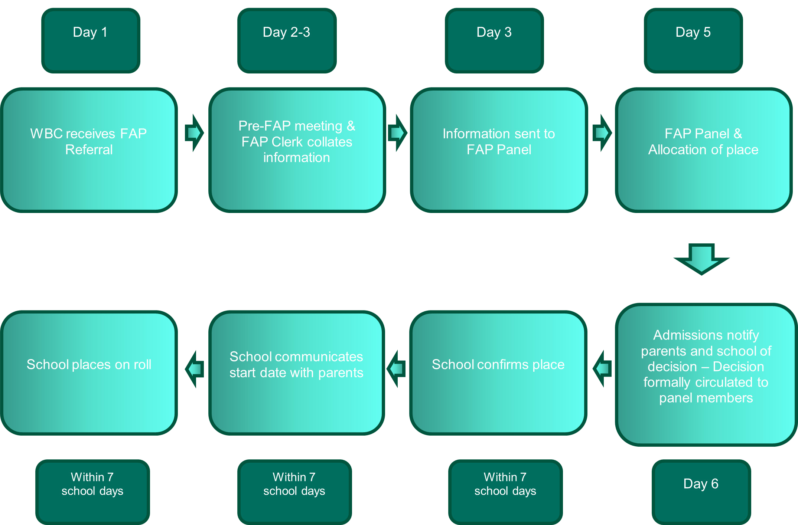

FAP process - Unsuccessful
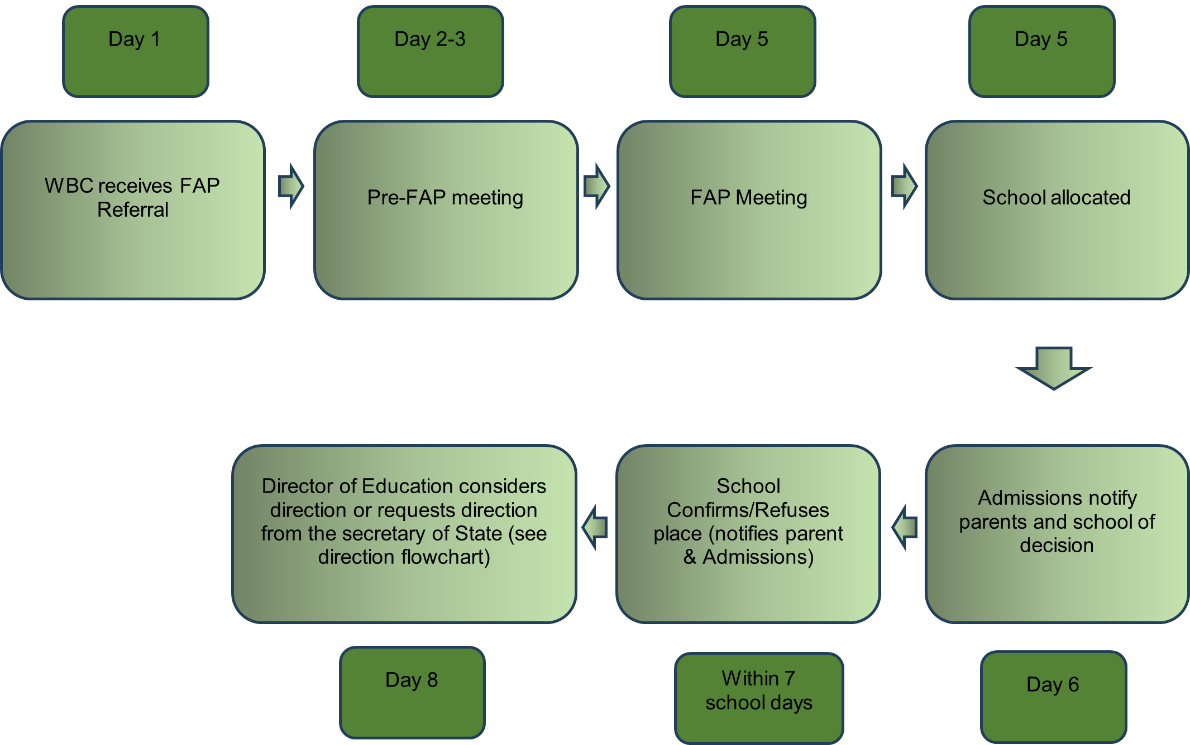

APPENDIX E - FLOWCHARTS – SUCCESSFUL/UNSUCCESSFUL DIRECTION

FAP process – Direction
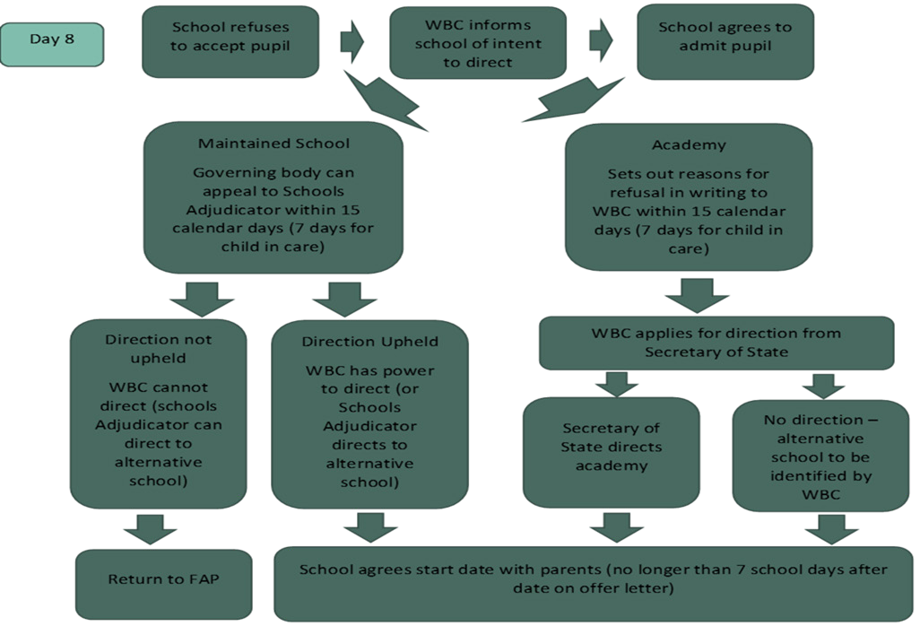

FAP process - Challenging Behaviour
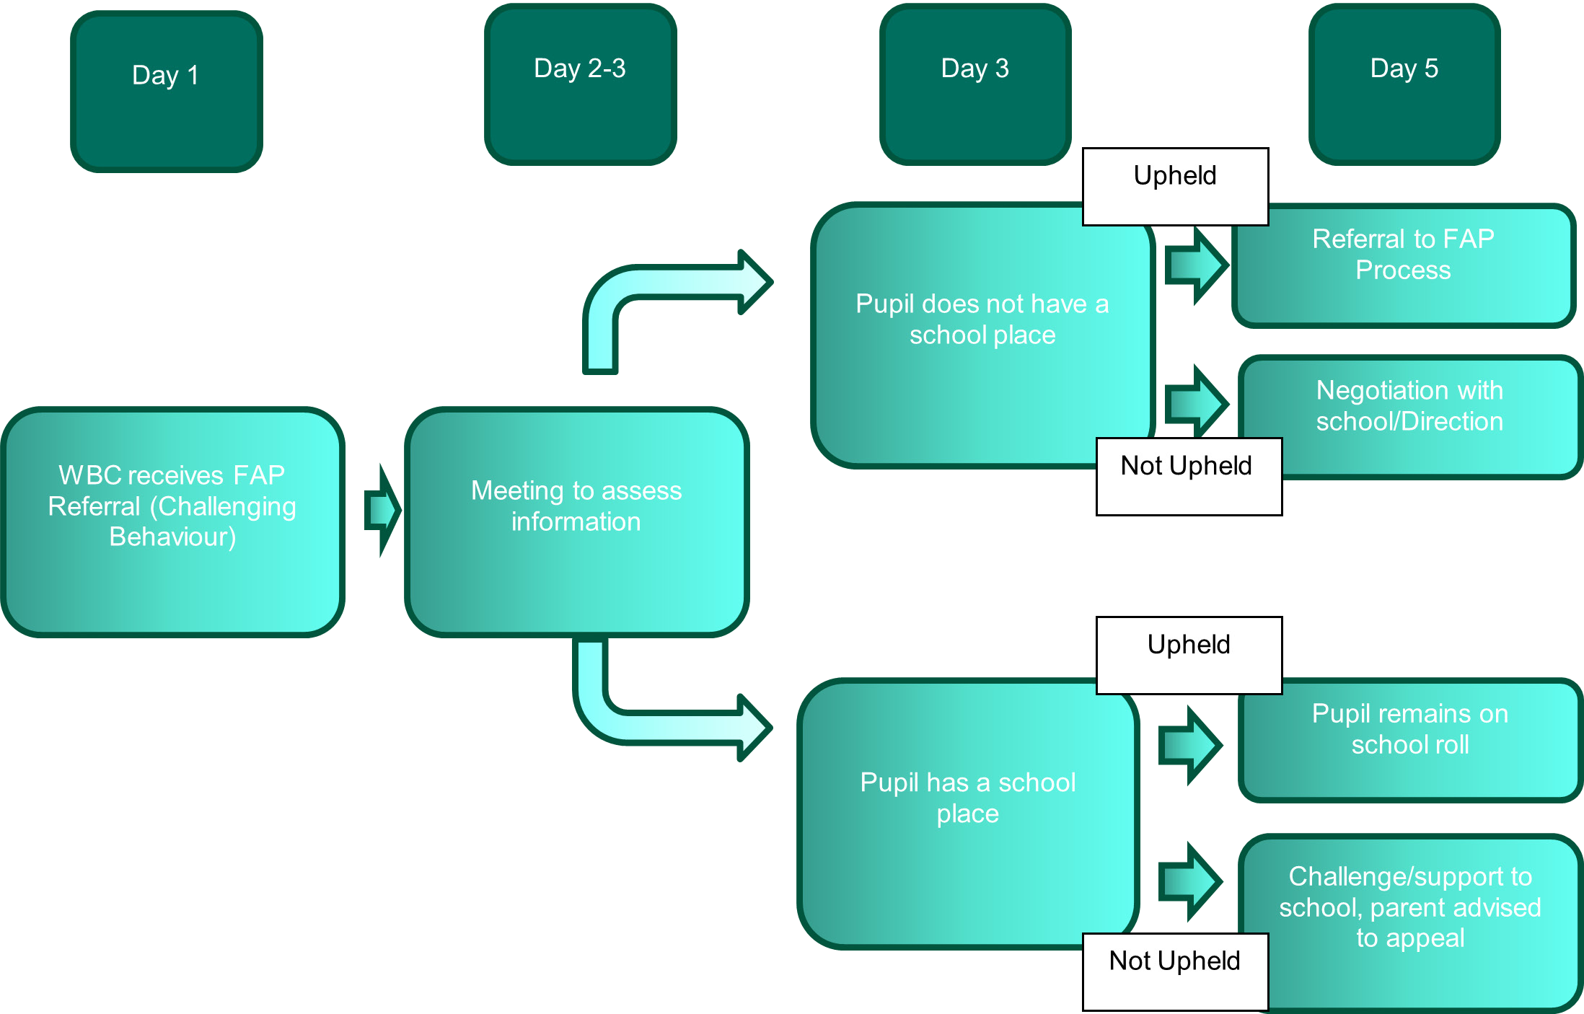

APPENDIX F – PUPIL PLACEMENT PANEL
INTRODUCTION

The FAP Panel will also be used (but not within statute) to place pupils in iCollege, short-term Alternative Provision Placements. This allows iCollege placements to be open, transparent and monitor disproportionality. There is also a budgetary implication.
- Placing pupils into short term alternative provision placement at iCollege
- Placing pupils who are unable to access mainstream into a longer term placement at iCollege
- Support and challenge
- Support off-site directions between schools and any managed movements Key Principles:
- Pupils being placed in iCollege Alternative Provision will return to their home school after a period of intervention
- Places will be allocated on a needs basis and space provision availability will be considered
- Referrals will be completed in full by the school and presented to the panel for consideration

PUPILS ELIGIBLE FOR PPP

- pupils looking to move from one mainstream to another through a Managed Move
- pupils eligible for a short-term placement at Alternative Provision through iCollege

PUPIL PLACEMENT PANEL STRUCTURE

- The meeting will be clerked by the FAP Clerk who will also have placement data available at every meeting showing trends and fair access.
- Using the pre-meeting for the FAP, available places and referrals will be discussed
- All members of the panel will be sent an agenda and agreed case details prior to the meeting.
- Meeting dates and venues will be prepared for the whole academic year and circulated to panel members.
- The Local Authority representative will ensure admissions and finance are aware of outcomes

PUPIL PLACEMENT PANEL - CONSIDERATIONS

- Whether alternative provision is ‘suitable’ and ‘efficient’ education for the pupil
- Year 11 pupils in Alternative Provision placements at iCollege
- Where appropriate, a financial package of support could be provided from the High Needs Block for use of additional support including E.P. Assessments, counselling services and one to one support
PANEL MEMBERS

- The membership of the additional Pupil Placement Panel will mirror the FAP Panel and for ease discussion will occur before the additional FAP referrals are discussed or where necessary.

FINANCIAL ARRANGEMENT

- The AWPU follows the pupil placement.
- Where a pupil is Dual Rolled with iCollege on an Alternative Provision short-term placement agreed at panel, the Local Authority will commission 50% of the placement cost or as agreed at school’s forum
- Where Year 11 pupils are sole registered at iCollege then the AWPU is transferred to iCollege as reported on the census.
- Similar funding will be arranged for pupils not permanently excluded when transferring between West Berkshire schools when considered appropriate by either panel.
PUPIL PLACEMENT BUDGET

A financial resource has been created to support the movement of pupils, back into mainstream or between mainstream schools, and to assist with reintegration. This may be accessed for short term assistance which may include an Education Psychology assessment, one to one support, counselling or catch-up tutoring. This budget is held by the Director of Education.
PROCEDURE FOR REFERRAL TO THE PUPIL PLACEMENT PANEL

- The Referral Form to be completed and forwarded to the Integration Manager supporting the PPP meeting. Referrals can be made by the Headteacher of a school for Alternative Provision placement

- Additional information with the referral form helps to ensure a placing in the best interest of the pupil. Additional information could include but not limited to:
  - Latest school report;
  - Behaviour log;
  - Record of academic levels;
  - Statements from other agencies involved;
  - Professional reports e.g. Educational Psychologist, Speech and Language Therapist etc.;
  - Suspension information, if relevant
  - Record of behaviour intervention and strategies used.

- Prior to submission, the referral form should be reviewed with parents. Parents’ school preferences and reasons should be obtained, and the school should verify that parents agree to the referral.

- The completed form needs to be with the Inclusion Manager at least five working days before the pre-meeting. These dates will be identified and shared for the whole academic year. Late referrals will be considered at the discretion of the Inclusion Manager.

- A pre-meeting will be held with the Inclusion Manager and PPP chair five days prior to PPP to review cases and paper work.

OUTCOME OF PANELS

Pupil Placement Panel decision

- Dual registration with a mainstream school and alternative provision;
- Full-time single registration at an alternative provision in cases of Year 11 pupils
- Decisions will be provided in writing to relevant school(s) and others involved, including parents or carers. This will include any financial implications.
- Admission to and registration with the identified provision will be within ten working days from receipt of the outcome of the PPP meeting in writing. This will be monitored by the Exclusions and Re-integrations Manager.

APPENDIX G - DATA SHARING PROTOCOL TO SUPPORT FAIR ACCESS PANEL

KEY PRINCIPLES:

- The Schools Admissions Code September 2021 requires all admission authorities to participate in the Fair Access Protocol to ensure that unplaces children are allocated to a school place quickly. The purpose of the Fair Access Protocol is to ensure that outside the normal admissions round unplaces children, especially the most vulnerable, are found and offered a place quickly, so that the amount of time any child is out of school is kept to a minimum. The panel brings together key partners, stakeholders and providers to achieve this.

- The Fair Access Panel report, as necessary, to a more strategic group (Schools Forum and Children’s Service Senior Leadership Team) to identify themes or issues that cause barriers to education provision.

- The Fair Access Panel may include representatives from the following:

  - Any West Berkshire Council agency
  - Police
  - West Berkshire Secondary Schools
  - West Berkshire Primary Schools
  - And any other party invited to engage in the Fair Access Protocol

- This data sharing protocol seeks commitment to a framework to ensure secure and appropriate sharing of information and data by agencies operating within the panel.

- The analysis and evaluation of educational data is central to the panel process, and the responsible sharing of data and information provides the basis for involvement to ensure young people do not miss out on education and to ensure sound decision making.

- The data to be provided by West Berkshire Council may include and relate to (but not necessarily limited to):

  - Attainment
  - Attendance
  - Exclusions

- Data will be provided in various formats as agencies may use different recording databases but will only be shared with those members of the FAP Panel who need the data to perform their professional duties.

- All members of the panel agree to share activities carried out by members of the panel to ensure that all young people have access to a quality education provision; and to monitor the impact of the panel.

- All recipients of data shared under this protocol are required to use it in a professional manner to promote;
  - Full-time education for ALL children
  - Mutual support
  - The improvements of outcomes for children and young people

- This protocol expressly excludes the use of shared data to;
  - Discriminate against a child or establishment
  - Provide the data to any third party

- All data recipients are required to ensure that the data they use, download, store or print is appropriately protected and in line with policy. This includes, where necessary, the encryption of data, its secure storage and disposal.

- Breach of these protocols by any signatory will be investigated and future access ay be denied.

Agreement: We the undersigned do hereby agree to implement the terms and conditions of this protocol

Organisation | Name | Signature | Date

Please return signed agreement to admissions@westberks.gov.uk

APPENDIX H - PARENTAL VIEWS FOR CONSIDERATION AT FAP

Pupil Details
Surname
Forename
Date of Birth (DD/MM/YYYY)
Home Address | Address line 1
 | Address Line 2
 | Town
 | County
 | Postcode
Gender
Ethnicity
Home Language
Religion
Family Details
Parent/Carer Name
Parent/Carer Telephone Number
Parent/Carer Email Address
Parent/Carer Preference
Parent/Carer in Agreement with FAP referral
Pupil Aware and in Agreement As above
Any additional information from parents relevant to application:

List of School Preferences:
Name of school: | Reason for preference: | Distance from home:

Name in Capitals | Signature | Date

