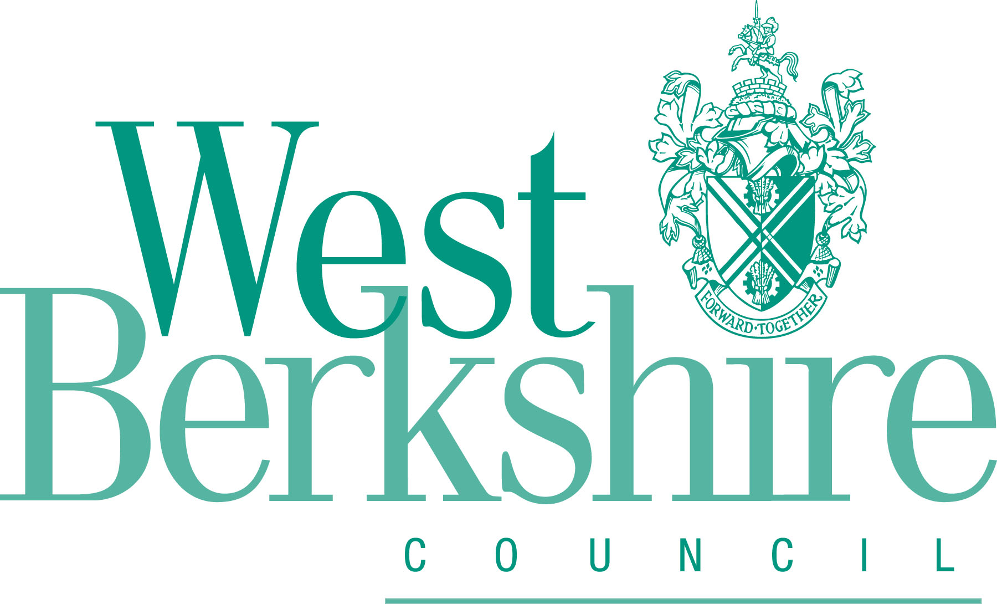 | Minerals and Waste Local Plan  Proposed Main Modifications Representation Form  Ref:  (For official use only)

Please complete online or return this form to: | Online: http://consult.westberks.gov.uk/kse.
Please complete online or return this form to: | By email: mwdpd@westberks.gov.uk
Please complete online or return this form to: | By post: Minerals and Waste, Development and Planning, Council Offices, Market Street, Newbury, RG14 5LD
Return by: | 17:00 Wednesday 6th July 2022

This form has two parts:
Part A – Your Details: need only be completed once
Part B – Your representation(s). Please fill in a separate sheet for each representation you wish to make.

PART A: Your Details

Please note the following:

- We cannot register your representation without your details.
- Representations cannot be kept confidential and will be available for public scrutiny, however, your contact details will not be published.
- All information will be sent for examination by an independent inspector
- All personal data will be handled in line with the Council’s Privacy Policy on the Development Plan. You can view the Council’s privacy notices at http://info.westberks.gov.uk/privacynotices

 | - Your details | - Agent’s details (if applicable)
Title
First Name*
Last Name*
Job title
(where relevant)
Organisation
(where relevant)
Address*
Please include postcode
Email address*
Telephone number
*Mandatory Field
Part B – Your Representation

Please use a separate sheet for each representation

Your representation should only relate to the Proposed Main Modifications to the plan. No fresh comments on the submission version of the plan will be considered.

Comments on the updates to the Sustainability Appraisal (and relevant appendices), and documents EXAM8 – 15 may be considered where relevant (noting that EXAM 16 – 19 were merely copies of previously submitted documents appended to EXAM 15). Comments are also invited on the updated Habitat Regulations Assessment (HRA).

Your name or organisation (and client if you are an agent):

Please indicate which of the following this representation relates to:
Main Modification reference:
EXAM doc reference:
SA reference:
HRA reference:

1. Legally Compliant
Legal compliance is judged against the requirements of Sections 19 and 20 of the Planning and Compulsory Purchase Act 2004 (as amended), including compliance with the Council’s Local Development Scheme, Statement of Community Involvement and the Town and Country Planning (Local Planning) (England) Regulations) 2012.
In addition, the Planning and Compulsory Purchase Act 2004 requires a Sustainability Appraisal (SA) and a Strategic Environmental Assessment (SEA) to be carried out, this can be done in a single appraisal process. The objective of the SA is to promote sustainable development through the integration of social, environmental and economic considerations in the preparation of the Minerals and Waste Local Plan.

European legislation and government regulations mean that a Habitats Regulations Assessment (HRA) needs to be carried out for the DPD, in order to protect the integrity of internationally important nature conservation sites. The HRA assesses the likely impacts of the policies of the DPD and possible ‘in combination’ effects with other policies and proposals.
Do you consider the Minerals and Waste Local Plan (Proposed Main Modifications) is legally compliant?

Yes |  | No

Please give reasons for your answer:
2. Soundness
The soundness of the Local Plan should be assessed against the following criteria from paragraph 35 of the National Planning Policy Framework:

(a) Positively prepared: providing a strategy which, as a minimum, seeks to meet the area’s objectively assessed needs; and is informed by agreements with other authorities, so that unmet need from neighbouring areas is accommodated where it is practical to do so and is consistent with achieving sustainability development.

(b) Justified: an appropriate strategy, taking into account the reasonable alternatives, and based on proportionate evidence;

(c) Effective: deliverable over the plan period, and based on effective joint working on cross-boundary strategic matters that have been dealt with rather than deferred, as evidenced by the statement of common ground; and

(d) Consistent with national policy: enabling the delivery of sustainable development in accordance with the policies in this Framework.

Do you consider the Minerals and Waste Local Plan (Proposed Main Modifications) is sound?

Yes |  | No

If no, please answer question 2b.

2b. Reasons for the Minerals and Waste Local Plan not being sound
Please tick all that apply.
Tick
Positively Prepared: The plan provides a strategy which, as a minimum, seeks to meet the area’s objectively assessed need and is informed by agreements with other authorities, so that unmet need from neighbouring areas is accommodated where practical to do so and is consistent with achieving sustainable development
Justified: the plan is an appropriate strategy, taking into account the reasonable alternatives, and based on proportionate evidence
Effective: the plan is deliverable over the plan period and based on effective joint working on cross-boundary strategic matters that have been dealt with rather than deferred, as evidenced by the statement of common ground
Consistent with national policy: the plan should enable the delivery of sustainable development in accordance with the policies of the NPPF

Please give reasons as to why you think the Plan is sound / unsound in light of the Main Modification(s) proposed:

3. Notification of Progress of the Minerals and Waste Local Plan

Do you wish to be notified of any of the following?
Please tick all that apply | Tick
The publication of the report of the Inspector appointed to carry out the examination
The adoption of the Minerals and Waste Local Plan
Please ensure that we have either an up to date email address or postal address at which we can contact you. You can amend your contact details by logging onto your account on the Local Plan Consultation Portal or by contacting the Minerals and Waste team.

Signature |  | Date

Your completed representations must be received by the Council by 17:00 on Wednesday 6th July 2022.

Planning and Compulsory Purchase Act 2014 (as amended): http://www.legislation.gov.uk/ukpga/2004/5/contents
Local Development Framework: www.westberks.gov.uk/lds
West Berkshire Council Statement of Community Involvement (2014): http://info.westberks.gov.uk/CHttpHandler.ashx?id=38265&p=0
Town and Country Planning (Local Planning) (England) Regulations) 2012: http://www.legislation.gov.uk/uksi/2012/767/introduction/made
National Planning Policy Framework (NPPF): https://www.gov.uk/government/publications/national-planning-policy-framework--2

